Practical 1
Aim: To create an AWS account and explore the AWS Global Infrastructure, including Regions and Availability Zones.
Part A — Check your Mumbai Region
At the top-right of the AWS Console, you should see something similar to:
Asia Pacific (Mumbai)
Region code:
ap-south-1
AWS currently lists Mumbai (ap-south-1) as an India Region, and its current documentation lists three Availability Zones for Mumbai. (AWS Documentation)
Region: A Region is a geographical area. We have selected Mumbai because we are working from India
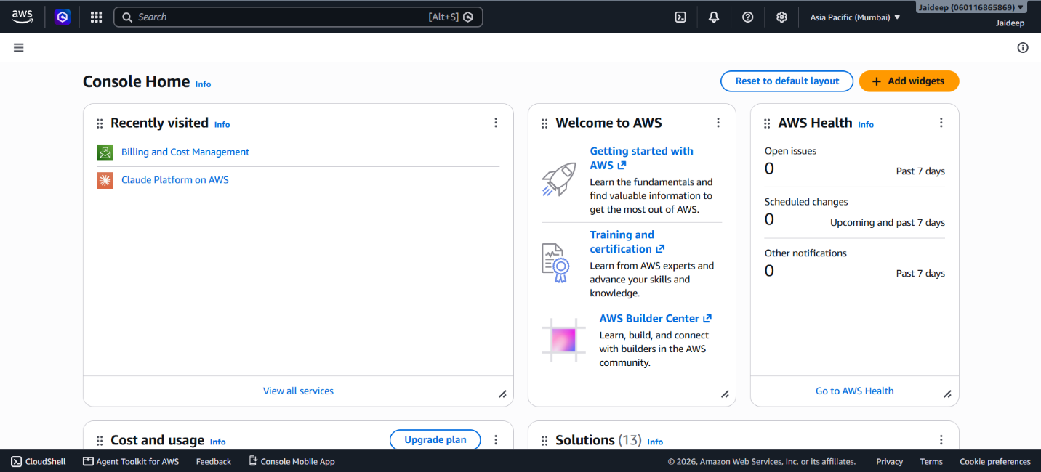
Part B — Explore Availability Zones
From the AWS Console:
Search → EC2
Then:
EC2 Dashboard → Instances
Look at the Availability Zone information when you create/view an instance.
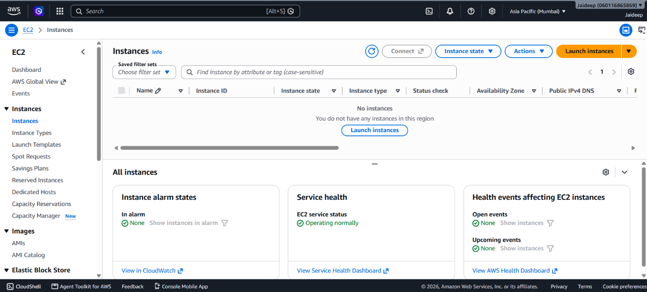
You can also explore:
EC2 → Network & Security → Subnets
There you can see Availability Zone information associated with subnets.
Observation
AWS provides cloud infrastructure in different geographical Regions. Each Region contains multiple Availability Zones. The Mumbai Region (ap-south-1) is an AWS Region in India and provides multiple Availability Zones.

